Chapter 9, Problem 64.

Find Z_{T} and I in the circuit shown in Fig. 9.71.
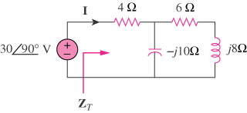

Figure 9.71
For Prob. 9.64.

